How ‘Self Narration’ Helps Outer Wilds Tell It’s Story
The concept of “emergent narrative” is a long-discussed phenomenon within video game discourse, describing a narrative that emerges from the interactions between a player and a fictional world. We can see this phenomenon give rise to a type of “self-narration” in Mobius Digital’s Outer Wilds (2019), as it carefully maintains player agency to more comfortably explore themes of existentialism and exploration. While emergent narrative is central to the self-narration of Outer Wilds, other key features of narrative structure such as asynchronous narrative, reliable/unreliable narration and multiple narrative levels additionally collaborate to give the player the ability to piece together its story.

Outer Wilds is a space exploration game, where the player character (the Hatchling) is a graduate of a fledgling space program by the Hearthians, an alien race on the planet Timber Hearth. The bulk of the game is spent traveling the solar system, trying to uncover the history and decode the ancient technology of an extinct race, the Nomai. However, very quickly the player realises two things:
- Whenever the Hatchling dies, they return back in time to that morning; they are stuck in a time loop and,
- No matter what happens in any loop, the sun will explode in a supernova after twenty-two minutes.
Aside from these constrains, the player is simply placed within the world of Outer Wilds, free to explore as they wish, with no objectives provided by the game beyond basic suggestions of planets to visit.

Before “self-narration” can be discussed further however, it is important to establish that Outer Wilds does actually make use of an emergent narrative to tell its story. In his article on emergent narrative, Richard Walsh (2011, p. 75) describes the basic concept of “emergence” as requiring two “levels of organisation”, an underlying system with predetermined “rules” and an abstracted higher level within which entities that interact within the base system form patterns. Walsh uses Conway’s Game of Life, a digital system where individual squares or “cells” on a grid shift between black or white over time, based on a set of underlying rules that change a cell’s state based on its neighbours. When the Game starts and the cells change under its rules, an external observer viewing the grid as a whole might notice that the black squares together form patterns of moving or rotating shapes, or in other words, an “emergent” pattern.
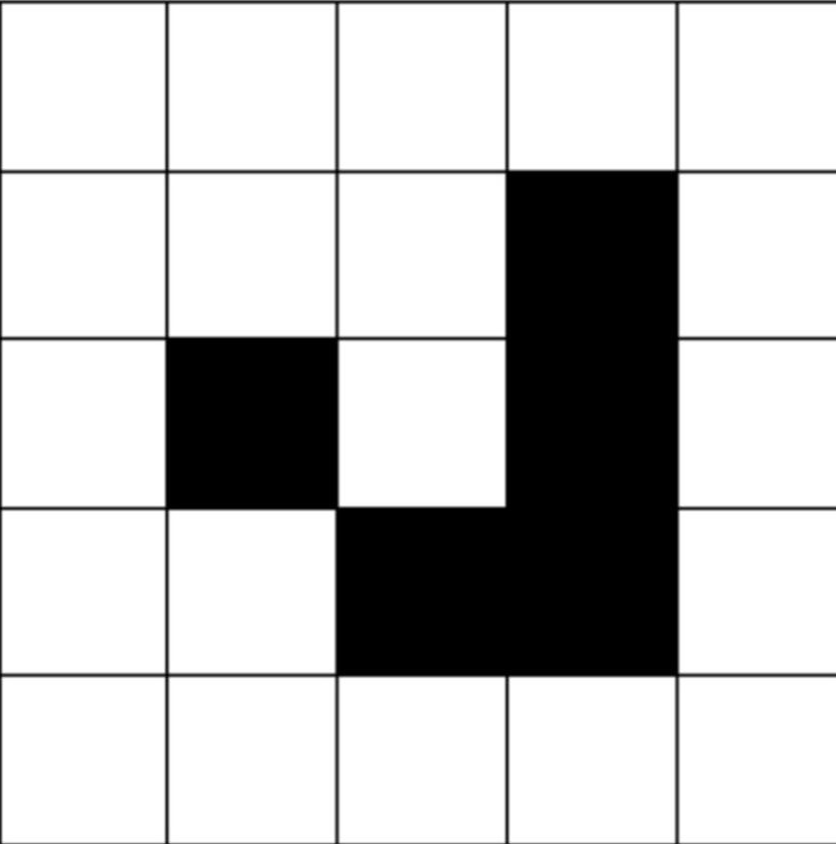
These emergent patterns are entirely distinct from the original system, in that the rules of the system do not describe for example, that the construction in this figure, known as a glider, is a distinct shape and will move across the screen when the Game is active. Instead, the rules of the system only describe that for a specific point in time within this grid these five specific squares are coloured black, and the rest are white. The glider only exists when seen from a level that is removed from the base system, and only as a composite of squares interacting on that base system.
Figure 1: “glider”
However, as Walsh claims (2011, p. 77), there is no narrative found on this higher level, only a set of emergent “behaviours” that collaborate to create a simulation of life. While the observer can attempt to narrativize these emergent behaviours, this is the narrative exists as a result of a “higher-level sense-making activity on the part of the user or observer” (Walsh, 2011, p. 77), similar to how we might narrativize the world around through our practice of “narrative accrual” (Bruner, 1991, p. 18), rather than directly emerging from the base system itself.
In order to find a narrative through emergence, we need a system where its interactions at the base level occur in a “semiotic” form, between units of meaning rather than units of action (Walsh, 2011, p. 79). In other words, at the base level we have a series of “communicative acts” or narrative instances which are necessarily intentional, and they convey fragments of representation or story which can additionally interact with “representational interventions” by the user. The combined intentionality of these communicative acts invites a sense of narrative interpretation rather than simply being a system that can be narrativized (Walsh, 2011, p. 81).
Understanding these criteria for emergent narrative, we can now identify them within the narrative structure of Outer Wilds. We have a base system where different elements or puzzles within the game environment are communicative acts prebuilt by Mobius Digital, which can interact on that base level with the Hatchling’s actions. As an example, the Southern Observatory informs the player about the mechanics of tornadoes on the planet Giant’s Deep and the character Feldspar notes that giant jellyfish can insulate against electricity. The player who guides the Hatchling’s exploration according to these units of meaning, allows the emergence of a narrative where the Hatchling explores the core of Giant’s Deep. Here, the interaction between the player character and the game environment exists at a lower narrative level than the level where a narrative emerges, and this interaction occurs according to the rules set by the base system: the player directs the Hatchling as though the player’s interests aligned with the logical interests of the player character and the features or puzzles of the various planets respond with knowledge that is directly related to the game universe.
In case someone might argue that rather than developing an emergent narrative, the player is simply navigating through a prebuilt hypertext narrative deliberately constructed by Mobius Digital, a “chose your own adventure”, we should consider a case where the player character does not exist, leaving the base elements of the game with nothing to interact with. For a regular hypertext narrative, all branching possibilities of narration already exist whether or not there is a reader, however in the case of Outer Wilds, the narrative of exploring Giant’s Deep would be entirely non-existent. Without the player’s interventions, the narrative acts which comprise the game environment cannot narrate anything alone.

Under Genette’s model of narrative (1979, p. 27), we know that a narrative is the discourse through which a story is delivered by a narrator. We now know that Outer Wilds delivers its story through means of emergent narrative, but this does not account for who narrates the game. In classical literary narrative, the narrator is typically a character or a representation of the implied author (Walsh, 1997, p. 495) through which an audience experiences the narrative. Therefore, a video game narrator has two clear possibilities: the player character, or the game developers through means of the camera.
For Outer Wilds, we can reasonably rule out the developers as narrators, as we know that its emergent narrative necessitates that developers only construct the communicative elements of the game environment; they cannot narrate directly, or the narrative cannot be emergent. The Hatchling is a more likely candidate as an autodiegetic narrator, though once again the criterion of emergent narrative would mandate that any narrator would exist on a higher level of narration than the player character on the base level, as the narrative itself exists on this higher level.
Ronny Chan (2022, p. 6) proposes the framework of a “player-narratee” being the of the game itself, given that the player is “addressed by some narrator” as evidenced by dialogue selection choices. While Outer Wilds does have a similar dynamic with dialogue selection, this framing could be opposed on the basis that calling the player a “narratee” would discount the level of agency a player has in an emergent narrative and that dialogue selection would just be a part of the representational interaction on a base level.
A form of “self-narrator” might be more compatible for this case, since the player, through emergent narrative, has a significantly increased level of control over what narrative they experience. Initially it might seem as though both the player and game environment they interact with to form an emergent narrative are equally responsible for narration, we must take into account that the game is a static, preprogramed set of elements within the base level, while the player has effectively infinite control over the game narrative, provided they are acting within the rules of the base level. In addition to this inherent imbalance, further structural elements of Outer Wilds’s narrative give the player an even greater sense of agency over how the story is narrated.

The communicative acts or narrative instances within the game environment of Outer Wilds are organised in a non-linear fashion. To reuse a previous example, both the Southern Observatory and the character Feldspar are on different planets to Giant’s Deep, therefore the player is prompted to actively travel across half the solar system in order to obtain the knowledge required to reach the planet’s core. The primary way that players learn information within Outer Wilds is by discovering and reading Nomai text. On The Writing Life podcast (Jones, McKenna, 2019) Lead writer Kelsey Beachum outlined three forms of this text:
- Surface Level Text
Surface level text is non-essential and can therefore be missed by the player without large narrative consequence. This form of text is typically located in obvious, easy to find locations, and written to capture player attention.
- Mid-Level Text
This text logically follows on from some surface level text but can just as effectively act as a starting point. This means that Mid-level text tends to be a complete narrative instance, requiring no external context to make sense of, and will hint at previous surface level or subsequent hidden level text. The text is a little more difficult to find than surface text and is usually located in a different location.
- Hidden Level Text
Hidden text is very difficult to find by accident, and typically communicates significant plot points for the larger story. This form of text often acts as a “reward” as a player reaches the end of a set of clues or solves some puzzle.
As these three forms of text are designed with varying levels of complexity, narrative instances can be “spread out” across the game environment while ensuring that players do not uncover significant information “too early”. This act of spreading out and creating a non-linear arrangement of narrative instances gives the player more freedom over which areas they explore first, therefore giving greater control to the self-narrator over how the chronology of the overall narrative is arranged.

It now becomes relevant to acknowledge that the narrative of Outer Wilds operates on three levels of narration. The previously mentioned “higher level” on which the emergent narrative is comprehensible acts as the primary extradiegetic layer of the self-narrator, while the “base level” can be interpreted as a secondary layer of intradiegetic, autodiegetic narration on the part of the Hatchling. However, stepping back from the framing of emergent narrative, we can see that the Nomai text itself exists on a third level of narration, where different Nomai homodiegetically narrate instances of their own lives. This third level of narration is where the question of reliability becomes relevant, as the narrators (unlike the self-narrator or the Hatchling) are no longer within the player’s immediate sphere of influence.
According to Greta Olsen’s model (2003, p. 104), readers judge narrator unreliability based on textual signals or a discordance between the reader and narrators’ values and attributes fallibility or untrustworthiness to them.
The Nomai however appear as incredibly reliable narrators on their written text, their conversations to each other always maintaining friendly and earnest undertones, which prompts players to construct a trustworthy opinion of them. Additionally, the player character can consistently test and verify claims that the Nomai make. When investigating the Nomai research on time travel technology, the player can use their ancient (and somehow still intact) lab equipment to create a time ‘portal’ of their own, and this external verification supports their record of infallibility. This level of trust that is built between the player and Nomai race creates an environment where the player begins to expect reliable answers at the end of any set of puzzles, which in turn reinforces the self-narrator’s ability to assemble the game’s narrative instances into a story. Since the player is initially external and a stranger to the world of Outer Wilds, as they gain a sense of familiarity and closeness to the Nomai’s story the self-narrator becomes more able to confidently construct and narrate the extradiegetic discourse for the game.
This sense of reliability has a strange effect on the self-narrator however, when the player encounters actual unreliable narrators in the form of the Strangers. The Strangers are a third sentient race in the solar system and unlike the Nomai are deeply secretive, live on a hidden ring-world and were introduced as additional content after the main game was released. Rather than text, the Strangers communicate through slide reels and projectors.
No matter which section of the ring-world players explore first, they are guaranteed to first find slide reels with frames that appear deliberately burnt and are confronted with a clearly doctored and unreliable narrative across reels. Players who have “completed” the main game will additionally notice that the Strangers misinterpret the purpose of “The Eye”, a mysterious celestial body that the Nomai spent their lives searching for, showing them as fallible narrators as well.
Despite this, in all playthroughs I’ve watched online and of my friends who played the game, players consistently continue to explore the ring-world, with the expectation there still exists communicative instances of the missing information and that the self-narrator will be able to eventually construct an accurate narrative of the Strangers. While the game environment does end up justifying this attitude by still providing answers, this initial assumption seems strange given the almost hostile first impression of the Strangers. We can rationalise this phenomenon by considering how players are likely first encounter this group after becoming intimately familiar with the Nomai and other Hearthians and are therefore conditioned by the friendliness and openness of other characters to expect both accurate and reliable answers from the Strangers. The self-narrator and in turn the player’s confidence has been reinforced by the totality of the game so far, that the player is able to extradiegetically narrate the intradiegetic representation of the Strangers.
There are no playthroughs online to substantiate this next claim, but it is possible that if a player was to encounter the Strangers before any other characters in Outer Wilds, their perspective on exploration and their expectations on finding answers may be vastly different to the average player.
Understanding how self-narration works in Outer Wilds finally allows us to explore how this narrative structure affects a player’s reception of its story and themes. The concept of existentialism is central to the story of Outer Wilds, where the player is consistently reminded and obstructed by of the vastness of cosmic and planetary forces including the giant tornadoes on Giant’s Deep, the black hole at the centre of Brittle Hollow or even just the Sun going supernova on every iteration of the time loop. The feature of self-narration plays a key role here in maintaining player autonomy and ensuring that any narrative the player experiences is essentially one which they themselves have chosen to experience. Regarding these existential threats, most self-narrators learn to integrate them into their own narrative, acknowledging these forces as just another part of their narrative of exploring the solar system. The important thing to note here is that while the game never compels this attitude, the self-narrator subconsciously “chooses” to adopt and internalise an unafraid approach to the once foreboding threats of the game environment. The element of choice here is what makes the delivery of this theme particularly effective.
As the story is self-narrated, maintaining the impression of choice, Outer Wilds stokes players’ curiosities and explorative instincts. Since the game never tells players to find anything, every trail the player follows and every answer they receive is compounded in significance by the fact that the player went “out of their way” to look for these answers. Beachum’s concerns about the game being “text heavy” (Jones, McKenna, 2019) were completely undercut by its narrative structure which ensures that the player personally choses to learn and include into their narrative, every bit of information that they learn.
The Eye, which was mentioned previously, is revealed over the course of gameplay to be central to the story world, and part of the “ending” for the game. As the Hatchling learns more about Nomai technology and their quest to find they Eye, the player can piece together a way to escape the time loop and visit the Eye themselves. Upon doing so, the player will initiate a sequence of events upon which the current, already dying universe will end and a new one will be reborn, a culmination of Outer Wilds’s themes of being unafraid of inevitable cosmic forces. While such an ending sounds horrific at face value, it is important to realise that by this point players have accepted their role in the greater cosmos and through self-narration have willingly chosen this sequence of events, maybe not knowing beforehand but certainly suspecting how the game might end. As the Nomai Solanum learnt through her own search for the eye, “the universe is, and we are”.

References
Bruner, J. (1991). The Narrative Construction of Reality. Critical Inquiry, 18(1), 1–21. https://doi.org/10.1086/448619
Chan, R. (2022). GAMEPLAY-AS-NARRATION: A narratological account of video games by way of Tokimeki Memorial 2 (pp. 1–25).
Guerlac, S., Genette, G., & Lewin, J. E. (1979). Narrative Discourse, an Essay in Method. MLN, 95(5), 1414. https://doi.org/10.2307/2906507
Jones, S., McKenna, S., (2019, July 5). Writing non-linear narratives with Outer Wilds' Kelsey Beachum [Audio podcast episode]. In The Writing Life. National Centre for Writing. https://writerscentre.podbean.com/e/51-writing-non-linear-narratives-with-outer-wilds-kelsey-beachum/
Olson, G. (2003). Reconsidering Unreliability: Fallible and Untrustworthy Narrators. Narrative, 11(1), 93–109. https://doi.org/10.1353/nar.2003.0001
Walsh, R. (1997). Who Is the Narrator? Poetics Today, 18(4), 495. https://doi.org/10.2307/1773184
Walsh, R. (2011). Emergent Narrative in Interactive Media. Narrative, 19(1), 72–85. https://doi.org/10.1353/nar.2011.0006

